Lillian Bayley Hoover
Presence in Absence
October 15, 2021 – December 10, 2021

the tender gravity of kindness, 2021
Oil on Dibond panel
24 x 36 inches

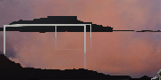 |  | slowly and then all at once, 2021  Oil on Dibond panel  18 x 36 inches

trying to remember something too important to forget, 2021
Oil on Dibond panel
30 x 20 inches

tension between (so many things, but also…), 2019
Oil on Dibond panel
12 x 36 inches

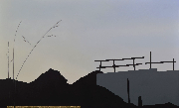 |  | no, the grief has not forgotten my name, but this morning I tied my shoelaces, 2021  Oil and gold leaf on Dibond panel  22 x 36 inches

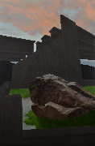 |  | here, witnessing, now, 2021  Oil and pastel pencil on Dibond panel  36 x 24 inches

but it completed nothing, 2021
Oil and gold leaf on wood panel
10 x 22 inches

to desire everything and nothing at once, 2021
Oil on Dibond panel
20 x 40 inches

learning how to hold hopelessness and hope together, 2020
Oil on wood panel
12 x 9 inches

to shrink or expand in the aftermath, 2020
Oil on Dibond panel
24 x 14 inches

strength in reserve, tension beneath the calm, 2018
Oil on Dibond panel
12 x 24 inches

draw alongside the silence of stone, 2020
Oil on wood panel
15 x 30 inches

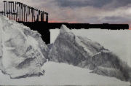 |  | every landscape is an accumulation, 2020  Oil and pastel pencil on Dibond panel  20 x 30 inches

when it stops haunting you, 2021
Oil and graphite on wood panel
20 x 30 inches

